E-Commerce Customer Churn
Predictive Analysis & Retention Insights
Objective | Identify drivers of customer churn and build a model to flag at-risk customers
Dataset | 5,630 e-commerce customers · 20 features (behavioral, transactional, demographic)
Methods | Exploratory data analysis · Logistic Regression · Random Forest · Gradient Boosting
Best model | Random Forest — 97% accuracy, 0.997 ROC-AUC, 82% recall on churners
Tools | Python · pandas · scikit-learn · seaborn / matplotlib · Jupyter Notebook

Executive Summary
This project analyzes 5,630 customer records from an e-commerce platform to understand what drives customer churn and to build a machine learning model that can flag at-risk customers before they leave. After cleaning the data and exploring behavioral patterns, three classification models were trained and compared. A Random Forest classifier emerged as the strongest performer, correctly identifying 82% of customers who churned while maintaining 97% precision — meaning retention efforts guided by this model would rarely be wasted on customers who were never going to leave.
The single strongest predictor of churn is customer tenure: churn is heavily concentrated among very new customers, with risk dropping sharply after the first few months. Cashback amount, complaint history, and delivery distance are secondary but meaningful factors. These findings point to a clear, actionable conclusion: retention efforts should be concentrated in the early customer lifecycle rather than spread evenly across the customer base.

1. Business Problem
Customer churn — the loss of existing customers — is one of the most direct threats to revenue in subscription and repeat-purchase businesses. Acquiring a new customer is typically far more expensive than retaining an existing one, which makes early identification of at-risk customers a high-value capability. This project addresses two questions:
- What customer attributes and behaviors are most strongly associated with churn?
- Can a predictive model reliably flag at-risk customers with enough accuracy to be useful for a real retention program?

2. Dataset Overview
The dataset contains 5,630 customer records with 20 columns spanning demographics (Gender, Marital Status), behavior (Tenure, Hours Spent on App, Order Count), service experience (Complaints, Satisfaction Score), and transactional detail (Cashback Amount, Order Amount Hike). The target variable, Churn, is binary (1 = churned, 0 = retained).
Rows | 5,630 customers
Columns | 20 (18 features + CustomerID + Churn)
Churn rate | 16.8% churned · 83.2% retained (imbalanced)
Feature types | Numeric (12) and categorical (6): device, payment mode, order category, gender, marital status, city tier

3. Data Cleaning & Quality Checks

3.1 Missing Values
Seven numeric columns had missing values, each affecting roughly 4.5% of records: Tenure, WarehouseToHome, HourSpendOnApp, OrderAmountHikeFromlastYear, CouponUsed, OrderCount, and DaySinceLastOrder. Given the small, consistent proportion of missingness, each column was imputed using its median value — a choice that is robust to outliers and avoids discarding otherwise complete customer records.

3.2 Duplicate Records
A full duplicate-row check confirmed zero duplicate records in the dataset.

3.3 Inconsistent Category Labels
Inspection of categorical columns revealed inconsistent labeling for the same real-world category: PreferredLoginDevice contained both “Phone” and “Mobile Phone” as separate values, and PreferedOrderCat contained both “Mobile” and “Mobile Phone”. These were merged into single consistent categories prior to analysis, since leaving them split would have diluted the true churn signal associated with each group and produced a misleading category-level breakdown.

4. Exploratory Data Analysis

4.1 Class Balance
Only 16.8% of customers in the dataset churned. This imbalance is important: a model that simply predicted “no churn” for every customer would already achieve 83.2% accuracy while being completely useless — which is why this analysis relies on precision, recall, and ROC-AUC rather than accuracy alone to judge model quality.
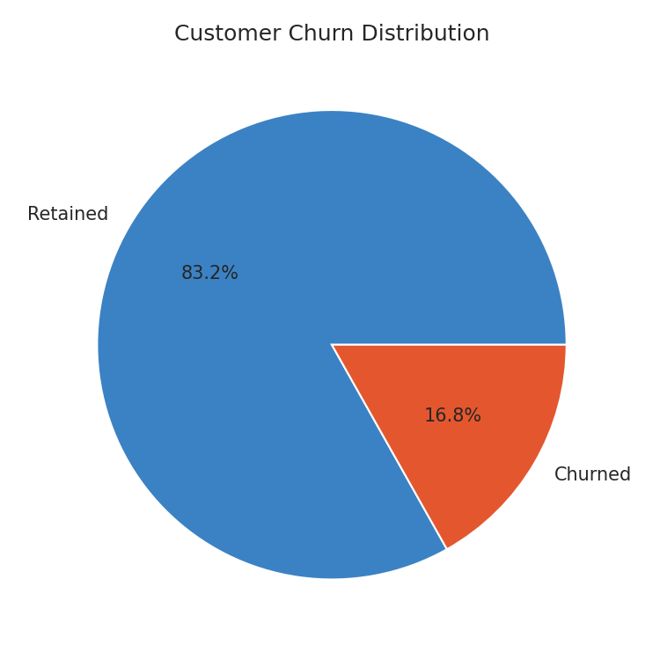
Figure 1. Overall churn distribution (16.8% churned).

4.2 Tenure — the Strongest Signal
Churned customers are heavily concentrated at very low tenure values, with density peaking near zero and dropping off sharply after roughly 10 units of tenure. Retained customers, by contrast, are spread broadly across the full tenure range. This is the clearest and most actionable pattern in the dataset: churn is predominantly a new-customer phenomenon, suggesting the first weeks of the customer relationship are the highest-leverage point for retention intervention.
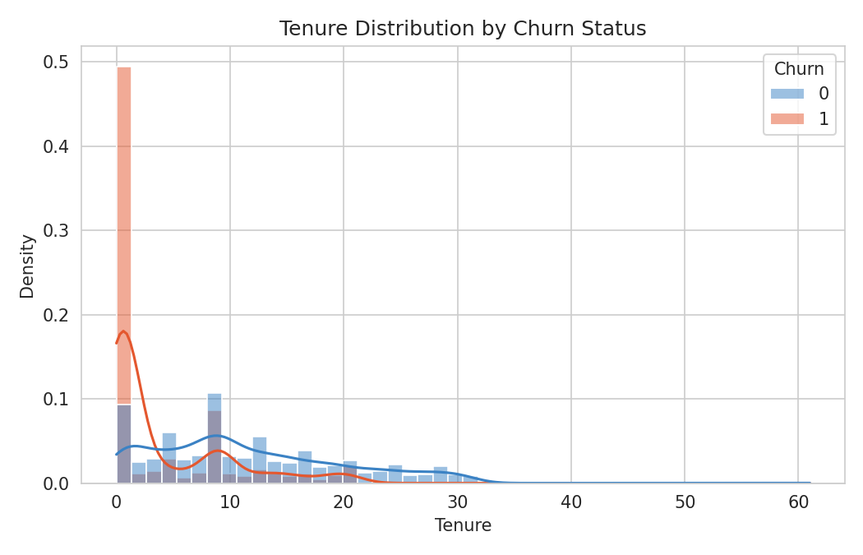
Figure 2. Tenure distribution by churn status.

4.3 Cashback Amount
Cashback amount shows a real but noisier relationship with churn. Both groups overlap substantially in the 100–200 range, but customers receiving higher cashback (250+) are disproportionately retained — very few high-cashback customers churn. This is a weaker, more directional signal than tenure rather than a sharp dividing line.
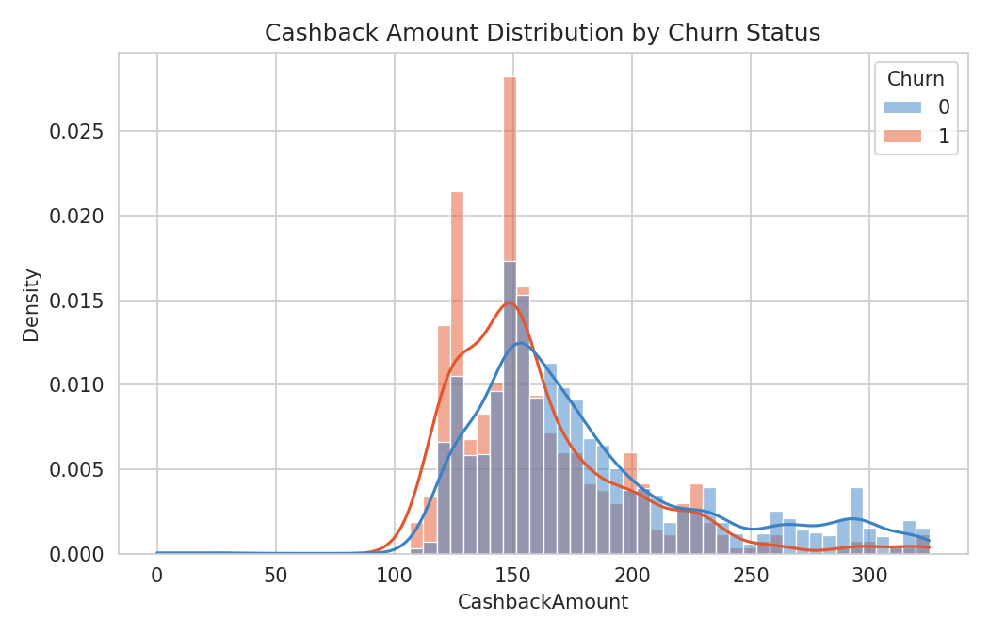
Figure 3. Cashback amount distribution by churn status.

4.4 Categorical Drivers
Marital status, preferred order category, and login device all show meaningful churn-rate differences once inconsistent labels were merged. Single customers churn at roughly 26.7%, more than double the rate of married customers (11.5%). Customers whose preferred order category is mobile phones churn at 27.4%, compared to just 4.9% for grocery-category shoppers.
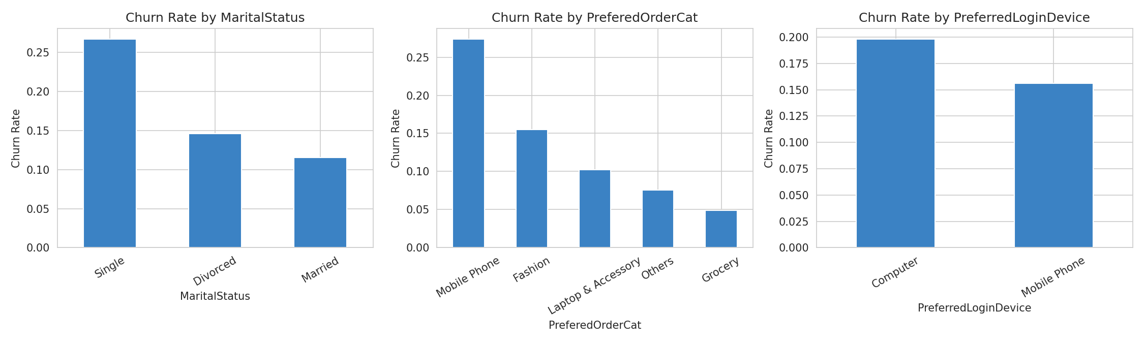
Figure 4. Churn rate by marital status, preferred order category, and login device.

5. Feature Engineering & Modeling Setup
Categorical variables were converted to numeric form using one-hot encoding, expanding the feature set from 18 to 26 usable predictor columns. The CustomerID column was excluded from modeling, as it is an arbitrary identifier with no genuine predictive value.
The data was split into training (80%) and test (20%) sets using stratified sampling to preserve the 16.8% churn rate in both partitions. All model evaluation is reported on the held-out test set only — data the models never saw during training — to ensure results reflect genuine generalization rather than memorization. For Logistic Regression, features were additionally standardized (zero mean, unit variance), since distance- and gradient-based optimization is sensitive to differences in feature scale; tree-based models (Random Forest, Gradient Boosting) do not require this step.

6. Model Building
Three classification models of increasing complexity were trained and compared:
- Logistic Regression — a linear baseline, fast and interpretable.
- Random Forest — an ensemble of decision trees that captures non-linear relationships and feature interactions.
- Gradient Boosting — sequentially trained trees, each correcting the errors of the previous ones.

7. Model Evaluation & Comparison
All three models are evaluated on the same held-out test set (1,126 customers) using precision, recall, F1-score, accuracy, and ROC-AUC. Recall on the churned class is treated as the most business-critical metric, since a missed churner (false negative) represents a lost customer with no chance for retention intervention, whereas a false positive simply results in an unnecessary but low-cost retention offer.
Model | Precision | Recall | F1-score | Accuracy | ROC-AUC
Logistic Regression | 0.77 | 0.55 | 0.64 | 0.90 | 0.886
Gradient Boosting | 0.82 | 0.67 | 0.74 | 0.92 | 0.944
Random Forest (best) | 0.97 | 0.82 | 0.89 | 0.97 | 0.997

Random Forest is the clear winner, outperforming the other two models on every single metric. It correctly identifies 82% of customers who actually churn (versus 55% for Logistic Regression), while maintaining 97% precision — meaning the model rarely raises a false alarm. Its near-perfect ROC-AUC (0.997) indicates it ranks churners above non-churners with very high reliability across any decision threshold.
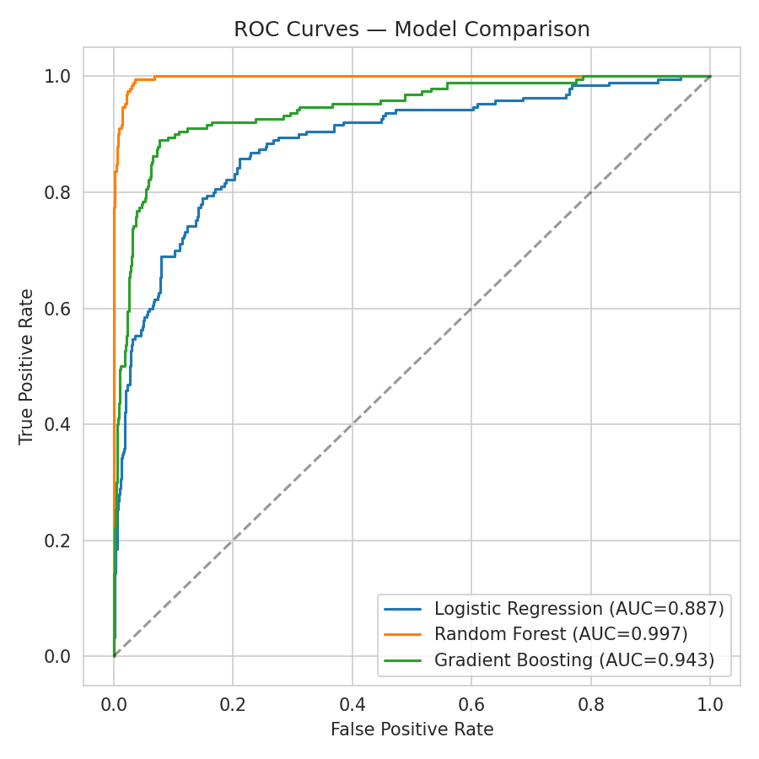
Figure 5. ROC curves comparing all three models.
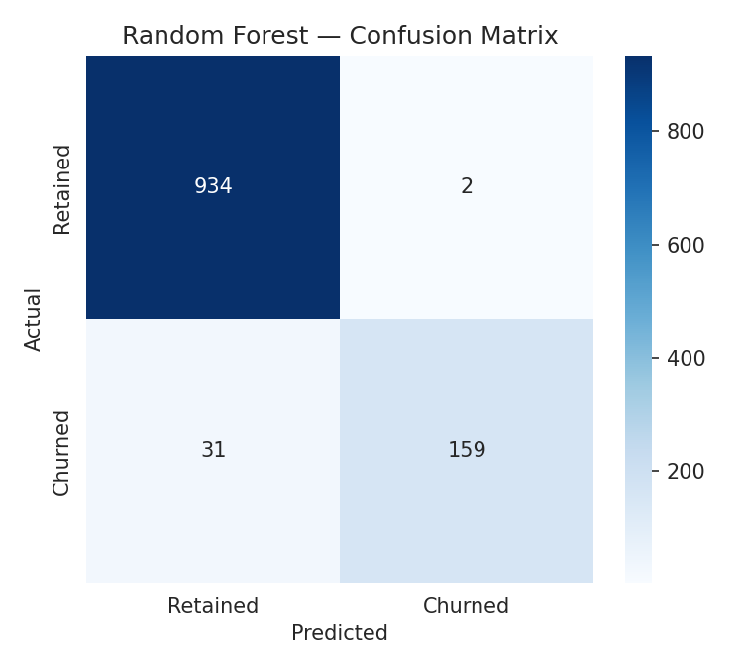
Figure 6. Confusion matrix for the Random Forest model (test set, n=1,126).

8. Feature Importance
Examining which features the Random Forest model relied on most confirms and extends the findings from exploratory analysis. Tenure is by a wide margin the most influential feature, consistent with the sharp separation observed earlier — the model independently rediscovered the same pattern found visually in the data. Cashback amount, complaint history, delivery distance, and number of registered addresses round out the next tier of importance.
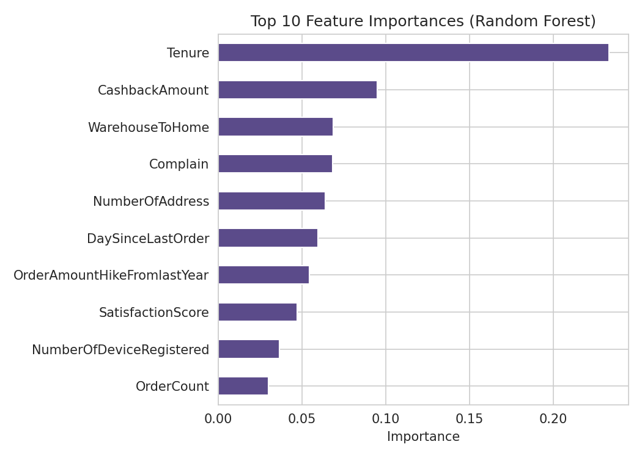
Figure 7. Top 10 feature importances from the Random Forest model.

9. Business Recommendations
- Prioritize onboarding and early-lifecycle engagement: since churn risk is heavily concentrated in the first weeks/months of tenure, a structured onboarding or early-check-in program is likely to have outsized impact on retention.
- Use cashback/incentive programs strategically: customers with higher cashback exposure churn less; consider proactive cashback offers for new or disengaging customers rather than only rewarding already-loyal ones.
- Route complaint-flagged customers to retention specialists: complaint history is a top-10 churn driver, making it a natural trigger for proactive outreach.
- Deploy the Random Forest model operationally: score active customers periodically and route the highest-risk segment to a retention workflow, leveraging the model's strong precision to avoid wasting outreach on customers unlikely to leave.

10. Conclusion & Next Steps
This analysis demonstrates a complete, defensible churn-prediction workflow: careful data cleaning (including catching inconsistent category labels that would have diluted results), exploratory analysis that surfaced clear and actionable patterns, and a model comparison that selected Random Forest as the strongest performer on business-relevant metrics rather than accuracy alone.
Suggested next steps include validating the model against more recent or entirely held-out data before production deployment, exploring cost-sensitive decision thresholds (adjusting the classification cutoff based on the relative cost of missed churners versus false alarms), and monitoring model performance over time as customer behavior evolves.

